



|  |
| --- |
| **BATCH AND ROLL NO: R6, 42257** |
| **EXPERIMENT NO.2** |
| **TITLE: Designing of mobile application to create home page using grid layout.** |
| **DATE OF PERFORMANCE** |
| **DATE OF CHECKING** |

**Title:** Designing of mobile application to create home page using grid layout.

**Requirements:**

1 Android studio

2. Java SDK

**Theory:**

Grid is merely a skeleton that helps arrange the items on page. Grid Layout is a layout manager that arranges the views in a grid. In Android GridLayout, we can specify the number of columns and rows that the grid will have. We can customize the GridLayout according to our requirements, like setting the size, color or the margin for the Layout. GridLayout basically places its children in a rectangular grid. This grid has a set of a number of thin lines that separatethe view area into cells. Suppose you have a grid of N columns, then we will have N+1 grid indices that would be starting from 0.



**Specifications ofAndroid GridLayout**

1. **Row and Columns**

The children can occupy the cells in contiguous cells, by defining them as follows:

**For rows:**

This defines the number of rows that would be occupied and how the children would aligned within the group of cells.

GridLayout.LayoutParams#rowSpec

**For Columns:**

This defines the number of columns that would be occupied and how the children would be aligned within the group of cells.

GridLayout.LayoutParams#columnSpec

1. **Default Cell Assignment**

If children do not have specified rows and columns then, the cell location is assigned automatically using the following:

* + GridLayout#setOrintation(int)
  + GridLayout#setRowCount(int)
  + GridLayout#setColumnCount(int)

**Attributes of Android GridLayout:**

The Specifications here describes the characteristics of the rows and columns of a group of cells. For a description of the characteristics of a GridLayout, we can use the followingXML Attributes:

* + android:alignmentMode – It sets the alignment of the margins and the boundaries.
  + android:columnCount – It sets the maximum number of columns to create when positioning children automatically.
  + android:columnOrderPreserved – It ensures that the column boundaries appear in the same order as its column indices.
  + android:rowCount – It set the maximum no. of rows to create when positioning children automatically.
  + android:rowOrderPreserved -It ensures that the row boundaries appear in the same order as its row indices.
  + android:useDefaultMargins – It tells the GridLayout to use margins if no margin is specified in the parameter. For this, it needs to be set on True.



Steps:

1. Create a New project in Android studio.
2. Add required dependencies.
3. Working with XML file
4. Open activity_main.XML file, which represents the UI of the project. Comments are added inside the code according to grid layout creation.

**Android layout commands**

<**androidx.constraintlayout.widget.ConstraintLayout** xmlns:android="<http://schemas.android.com/apk/res/android>" xmlns:tools="<http://schemas.android.com/tools>" android:layout_width="match_parent" android:layout_height="match_parent" tools:context=".MainActivity">

<**GridView**

android:id="@+id/idGVcourses" android:layout_width="match_parent" android:layout_height="match_parent" android:horizontalSpacing="6dp" android:numColumns="2" android:verticalSpacing="6dp" />

</**androidx.constraintlayout.widget.ConstraintLayout**>

**Code:**

<?xml version="1.0" encoding="utf-8"?>

<RelativeLayout xmlns:android=["http://schemas.android.com/](http://schemas.android.com/apk/res/android)a[pk/res/android"](http://schemas.android.com/apk/res/android) xmlns:t[ools="ht](http://schemas.android.com/tools)tp:/[/schemas.android.com/tool](http://schemas.android.com/tools)s" android:layout_width="match_parent"

android:layout_height="match_parent" xmlns:app=["http://sche](http://schemas.android.com/apk/res-auto)m[as.android.com/apk/res-auto"](http://schemas.android.com/apk/res-auto) tools:context=".MainActivity">

<GridLayout android:layout_width="match_parent" android:layout_height="match_parent"

android:columnCount="2" android:rowCount="3">

<androidx.cardview.widget.CardView android:layout_margin="18dp" android:elevation="8dp" app:cardCornerRadius="8dp" android:layout_width="wrap_content" android:layout_height="wrap_content" android:layout_row="0" android:layout_rowWeight="1" android:layout_columnWeight="1" android:layout_column="0" android:id="@+id/card00">

<LinearLayout android:layout_width="wrap_content" android:layout_height="wrap_content" android:orientation="vertical" android:gravity="center" android:layout_gravity="center">

<ImageView android:layout_width="wrap_content" android:layout_height="wrap_content" android:src="@drawable/baseline_home_24">

</ImageView>

<TextView android:layout_width="wrap_content" android:layout_height="wrap_content" android:text="Home">

</TextView>

</LinearLayout>

</androidx.cardview.widget.CardView>

<androidx.cardview.widget.CardView android:layout_margin="18dp" android:elevation="8dp" app:cardCornerRadius="8dp" android:layout_width="wrap_content" android:layout_height="wrap_content" android:layout_row="0" android:layout_column="1" android:layout_columnWeight="1" android:layout_rowWeight="1" android:id="@+id/card01">

<LinearLayout

android:layout_width="wrap_content" android:layout_height="wrap_content" android:orientation="vertical" android:layout_gravity="center" android:gravity="center">

<ImageView android:layout_width="wrap_content" android:layout_height="wrap_content" android:src="@drawable/baseline_contacts_24">

</ImageView>

<TextView android:layout_width="wrap_content" android:layout_height="wrap_content" android:text="Contact">

</TextView>

</LinearLayout>

</androidx.cardview.widget.CardView>

<androidx.cardview.widget.CardView android:layout_margin="18dp" android:elevation="8dp" app:cardCornerRadius="8dp" android:layout_width="wrap_content" android:layout_height="wrap_content" android:layout_row="1" android:layout_columnWeight="1" android:layout_rowWeight="1" android:layout_column="0" android:id="@+id/card10">

<LinearLayout android:layout_width="wrap_content" android:layout_height="wrap_content" android:orientation="vertical" android:gravity="center" android:layout_gravity="center">

<ImageView android:layout_width="wrap_content" android:layout_height="wrap_content"

android:src="@drawable/baseline_camera_alt_24">

</ImageView>

<TextView android:layout_width="wrap_content" android:layout_height="wrap_content" android:text="Camera">

</TextView>

</LinearLayout>

</androidx.cardview.widget.CardView>

<androidx.cardview.widget.CardView android:layout_margin="18dp" android:elevation="8dp" app:cardCornerRadius="8dp" android:layout_width="wrap_content" android:layout_height="wrap_content" android:layout_row="1" android:layout_columnWeight="1" android:layout_rowWeight="1" android:layout_column="1" android:id="@+id/card11">

<LinearLayout android:layout_width="wrap_content" android:layout_height="wrap_content" android:orientation="vertical" android:gravity="center" android:layout_gravity="center">

<ImageView android:layout_width="wrap_content" android:layout_height="wrap_content" android:src="@drawable/baseline_call_24">

</ImageView>

<TextView android:layout_width="wrap_content" android:layout_height="wrap_content" android:text="Call">

</TextView>

</LinearLayout>

</androidx.cardview.widget.CardView>

<androidx.cardview.widget.CardView android:layout_margin="18dp" android:elevation="8dp" app:cardCornerRadius="8dp" android:layout_width="wrap_content" android:layout_height="wrap_content" android:layout_row="2" android:layout_column="0" android:layout_columnWeight="1" android:layout_rowWeight="1"

android:id="@+id/card20">

<LinearLayout android:layout_gravity="center" android:layout_width="wrap_content" android:layout_height="wrap_content" android:orientation="vertical" android:gravity="center">

<ImageView android:layout_width="wrap_content" android:layout_height="wrap_content"

android:src="@drawable/baseline_feedback_24">

</ImageView>

<TextView android:layout_width="wrap_content" android:layout_height="wrap_content" android:text="Feedback">

</TextView>

</LinearLayout>

</androidx.cardview.widget.CardView>

<androidx.cardview.widget.CardView android:layout_margin="18dp" android:elevation="8dp" app:cardCornerRadius="8dp" android:layout_width="wrap_content" android:layout_height="wrap_content" android:layout_row="2" android:layout_column="1" android:layout_columnWeight="1" android:layout_rowWeight="1" android:id="@+id/card21">

<LinearLayout android:layout_gravity="center" android:layout_width="wrap_content" android:layout_height="wrap_content" android:orientation="vertical" android:gravity="center">

<ImageView android:layout_width="wrap_content" android:layout_height="wrap_content"

android:src="@drawable/baseline_calendar_month_24">

</ImageView>

<TextView

android:layout_width="wrap_content" android:layout_height="wrap_content" android:text="Calendar">

</TextView>

</LinearLayout>

</androidx.cardview.widget.CardView>

</GridLayout>

</RelativeLayout>







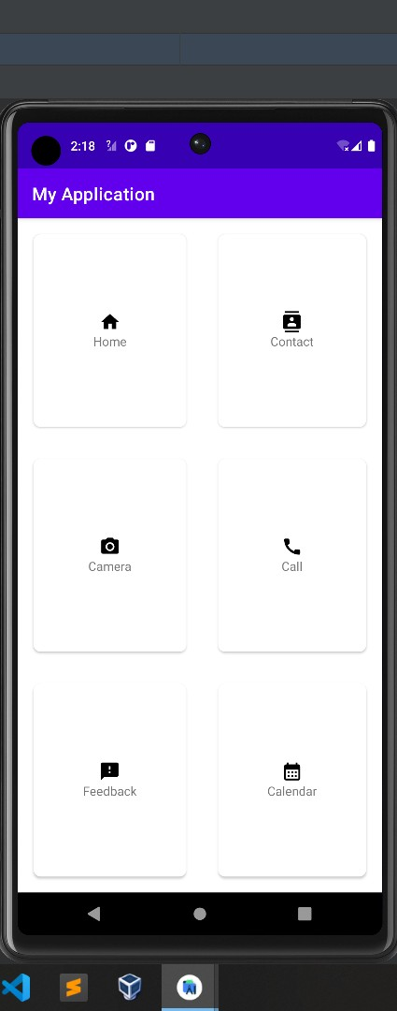

**Output:**

**CONCLUSION:**

**……………………………………………………………………………………………**

**……………………………………………………………………………………………**

**……………………………………………………………………………………………**